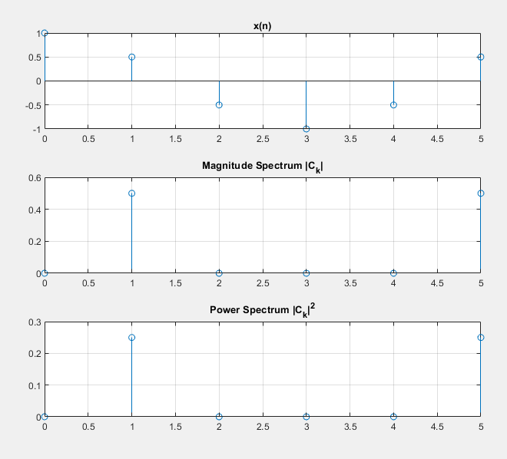
Exercise 1 & 2
N = 6;
n = 0:N-1;
x_n = cos(n * pi / 3);

Ck = DTFS(x_n, N);

[pow_xn, pow_Ck] = parsevals(x_n, Ck);

disp('DTFS Coefficients:');
disp(Ck);

disp('Power in time domain:');
disp(pow_xn);

disp('Power in frequency domain:');
disp(pow_Ck);

subplot(3,1,1);
stem(n, x_n);
title('x(n)');
grid on;

subplot(3,1,2);
stem(0:N-1, abs(Ck));
title('Magnitude Spectrum |C_k|');
grid on;

subplot(3,1,3);
stem(0:N-1, abs(Ck).^2);
title('Power Spectrum |C_k|^2');
grid on;

function Ck = DTFS(x, N)
Ck = zeros(1, N);
for k = 1:N
Ck(k) = (1/N) * sum(x .* exp(-1j * 2 * pi * (k-1) * (0:N-1) / N));
end
end

function [pow_xn, pow_Ck] = parsevals(xn, Ck)
pow_xn = sum(abs(xn).^2);
pow_Ck = length(xn) * sum(abs(Ck).^2);
end
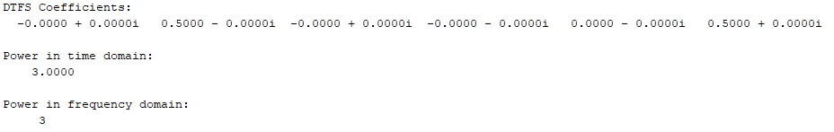

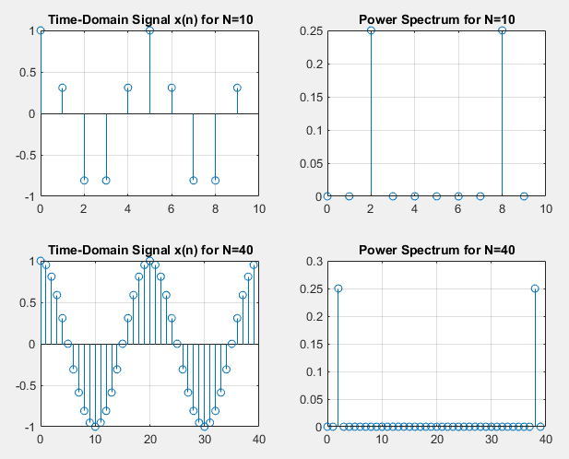
Exercise 3
L = 2;
A = 1;

% Case 1: N = 10
N1 = 10;
n1 = 0:N1-1;
x_n1 = A * cos((2 * pi * L / N1) * n1);

% Case 2: N = 40
N2 = 40;
n2 = 0:N2-1;
x_n2 = A * cos((2 * pi * L / N2) * n2);

Ck1 = DTFS(x_n1, N1);
Ck2 = DTFS(x_n2, N2);

[pow_xn1, pow_Ck1] = parsevals(x_n1, Ck1);
[pow_xn2, pow_Ck2] = parsevals(x_n2, Ck2);

disp('Power in time domain for N=10:'); disp(pow_xn1);
disp('Power in frequency domain for N=10:'); disp(pow_Ck1);

disp('Power in time domain for N=40:'); disp(pow_xn2);
disp('Power in frequency domain for N=40:'); disp(pow_Ck2);

% Case 1: N = 10
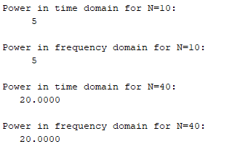
subplot(2,2,1);
stem(n1, x_n1);
title('Time-Domain Signal x(n) for N=10');
grid on;
subplot(2,2,2);
stem(0:N1-1, abs(Ck1).^2);
title('Power Spectrum for N=10');
grid on;

% Case 2: N = 40
subplot(2,2,3);
stem(n2, x_n2);
title('Time-Domain Signal x(n) for N=40');
grid on;
subplot(2,2,4);
stem(0:N2-1, abs(Ck2).^2);
title('Power Spectrum for N=40');
grid on;

function Ck = DTFS(x, N)
Ck = zeros(1, N);
for k = 1:N
Ck(k) = (1/N) * sum(x .* exp(-1j * 2 * pi * (k-1) * (0:N-1) / N));
end
end

function [pow_xn, pow_Ck] = parsevals(xn, Ck)
pow_xn = sum(abs(xn).^2);
pow_Ck = length(xn) * sum(abs(Ck).^2);
end

Exercise 4
function y = IDTFS(Ck, N)
y = zeros(1, N);

for n = 1:N
sum_val = 0;
for k = 1:N
sum_val = sum_val + Ck(k) * exp(1j * 2 * pi * (k-1) * (n-1) / N);
end
y(n) = sum_val;
end
end

Exercise 5
N1 = 10; % Case 1
N2 = 40; % Case 2

Ck1 = fftshift(fft([1 0 0 0 0 1 0 0 0 0]) / N1);
Ck2 = fftshift(fft([1 0 0 0 0 0 0 0 0 0 1 0 0 0 0 0 0 0 0 0 1 0 0 0 0 0 0 0 0 0 1 0 0 0 0 0 0 0 0 0] / N2));

x_reconstructed_1 = IDTFS(Ck1, N1);
x_reconstructed_2 = IDTFS(Ck2, N2);

subplot(2,1,1);
stem(0:N1-1, real(x_reconstructed_1));
title('Reconstructed x(n) for N=10');
grid on;

subplot(2,1,2);
stem(0:N2-1, real(x_reconstructed_2));
title('Reconstructed x(n) for N=40');
grid on;

function y = IDTFS(Ck, N)
n = 0:N-1;
k = (-floor(N/2)):(ceil(N/2)-1);
WN = exp(1j * 2 * pi / N);
y = real(sum(Ck .* (WN .^ (k' * n)), 1));
end
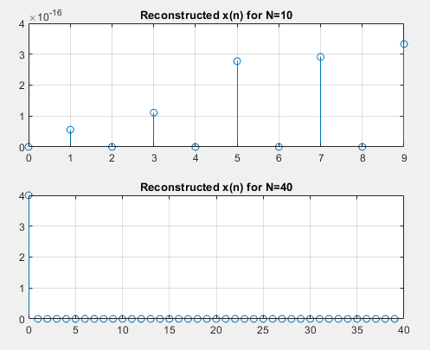

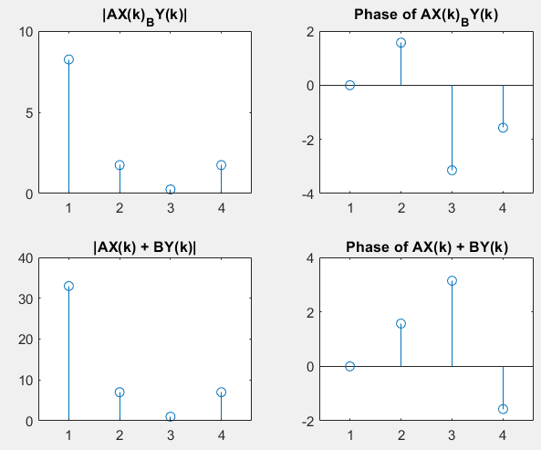
Exercise 6
N = 4;

xn = [1, 1, 1, 0];
yn = [2, 1, 2, 4];

A = 2;
B = 3;

Xk = DTFS(xn, N);
Yk = DTFS1(yn, N);

Axn_Byn = A * xn + B * yn;

Axk_Byk = fft(Axn_Byn);

AXk_BYk = A * Xk + B * Yk;

figure;
subplot(2,2,1);
stem(abs(AXk_BYk));title('|AX(k)_BY(k)|');

subplot(2,2,2);
stem(angle(AXk_BYk));title('Phase of AX(k)_BY(k)');

subplot(2,2,3);
stem(abs(Axk_Byk));title('|AX(k) + BY(k)|');

subplot(2,2,4);
stem(angle(Axk_Byk));title('Phase of AX(k) + BY(k)');

function Xk = DTFS(xn, N)
Xk = zeros(1, N);
for k = 1:N
Xk(k) = (1/N) * sum(xn .* exp(-1j * 2 * pi * (k-1) * (0:N-1) / N));
end
end

function Yk = DTFS1(yn, N)
Yk = zeros(1, N);
for k = 1:N
Yk(k) = (1/N) * sum(yn .* exp(-1j * 2 * pi * (k-1) * (0:N-1) / N));
end
end

Exercise 7
xn = [3 2 1 0];
N = length(xn);

n0 = 1;

Xk = DTFS(xn,N);

x_shifted = circshift(xn, -n0);

X_shifted_k = fft(x_shifted);

k = 0:N-1;
X_k_theoretical = Xk .* exp(-1j * 2 * pi * k * n0 / N);

subplot(2,2,1);
stem(k, abs(X_shifted_k));title('Magnitude of Shifted');

subplot(2,2,2);
stem(k, abs(X_k_theoretical));title('Magnitude of Theoretical');

subplot(2,2,3);
stem(k, angle(X_shifted_k));title('Phase of Shifted');

subplot(2,2,4);
stem(k, angle(X_k_theoretical));title('Phase of Theoretical');

function Xk = DTFS(xn, N)
Xk = zeros(1, N);
for k = 1:N
Xk(k) = (1/N) * sum(xn .* exp(-1j * 2 * pi * (k-1) * (0:N-1) / N));
end
end
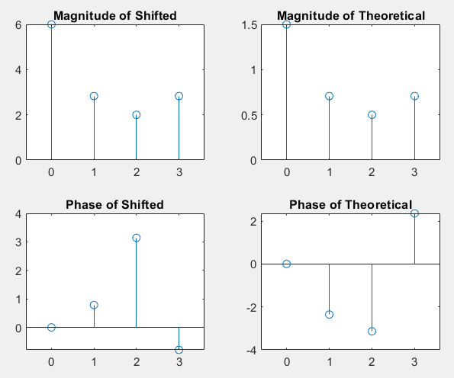
Post Lab
xn = [3 2 1 0];
N = length(xn);

k0 = 1;

Xk = fft(xn);

n = 0:N-1;
x_freq_shifted = xn .* exp(1j * 2 * pi * k0 * n / N);

X_shifted_k = fft(x_freq_shifted);

X_k_theoretical = circshift(Xk, -k0);

subplot(2,2,1);
stem(0:N-1, abs(X_shifted_k));title('Magnitude of Frequency Shifted');

subplot(2,2,2);
stem(0:N-1, abs(X_k_theoretical));title('Magnitude of Frequency Theoretical');

subplot(2,2,3);
stem(0:N-1, angle(X_shifted_k));title('Phase of Frequency Shifted');

subplot(2,2,4);
stem(0:N-1, angle(X_k_theoretical));title('Phase of Frequency Theoretical');

